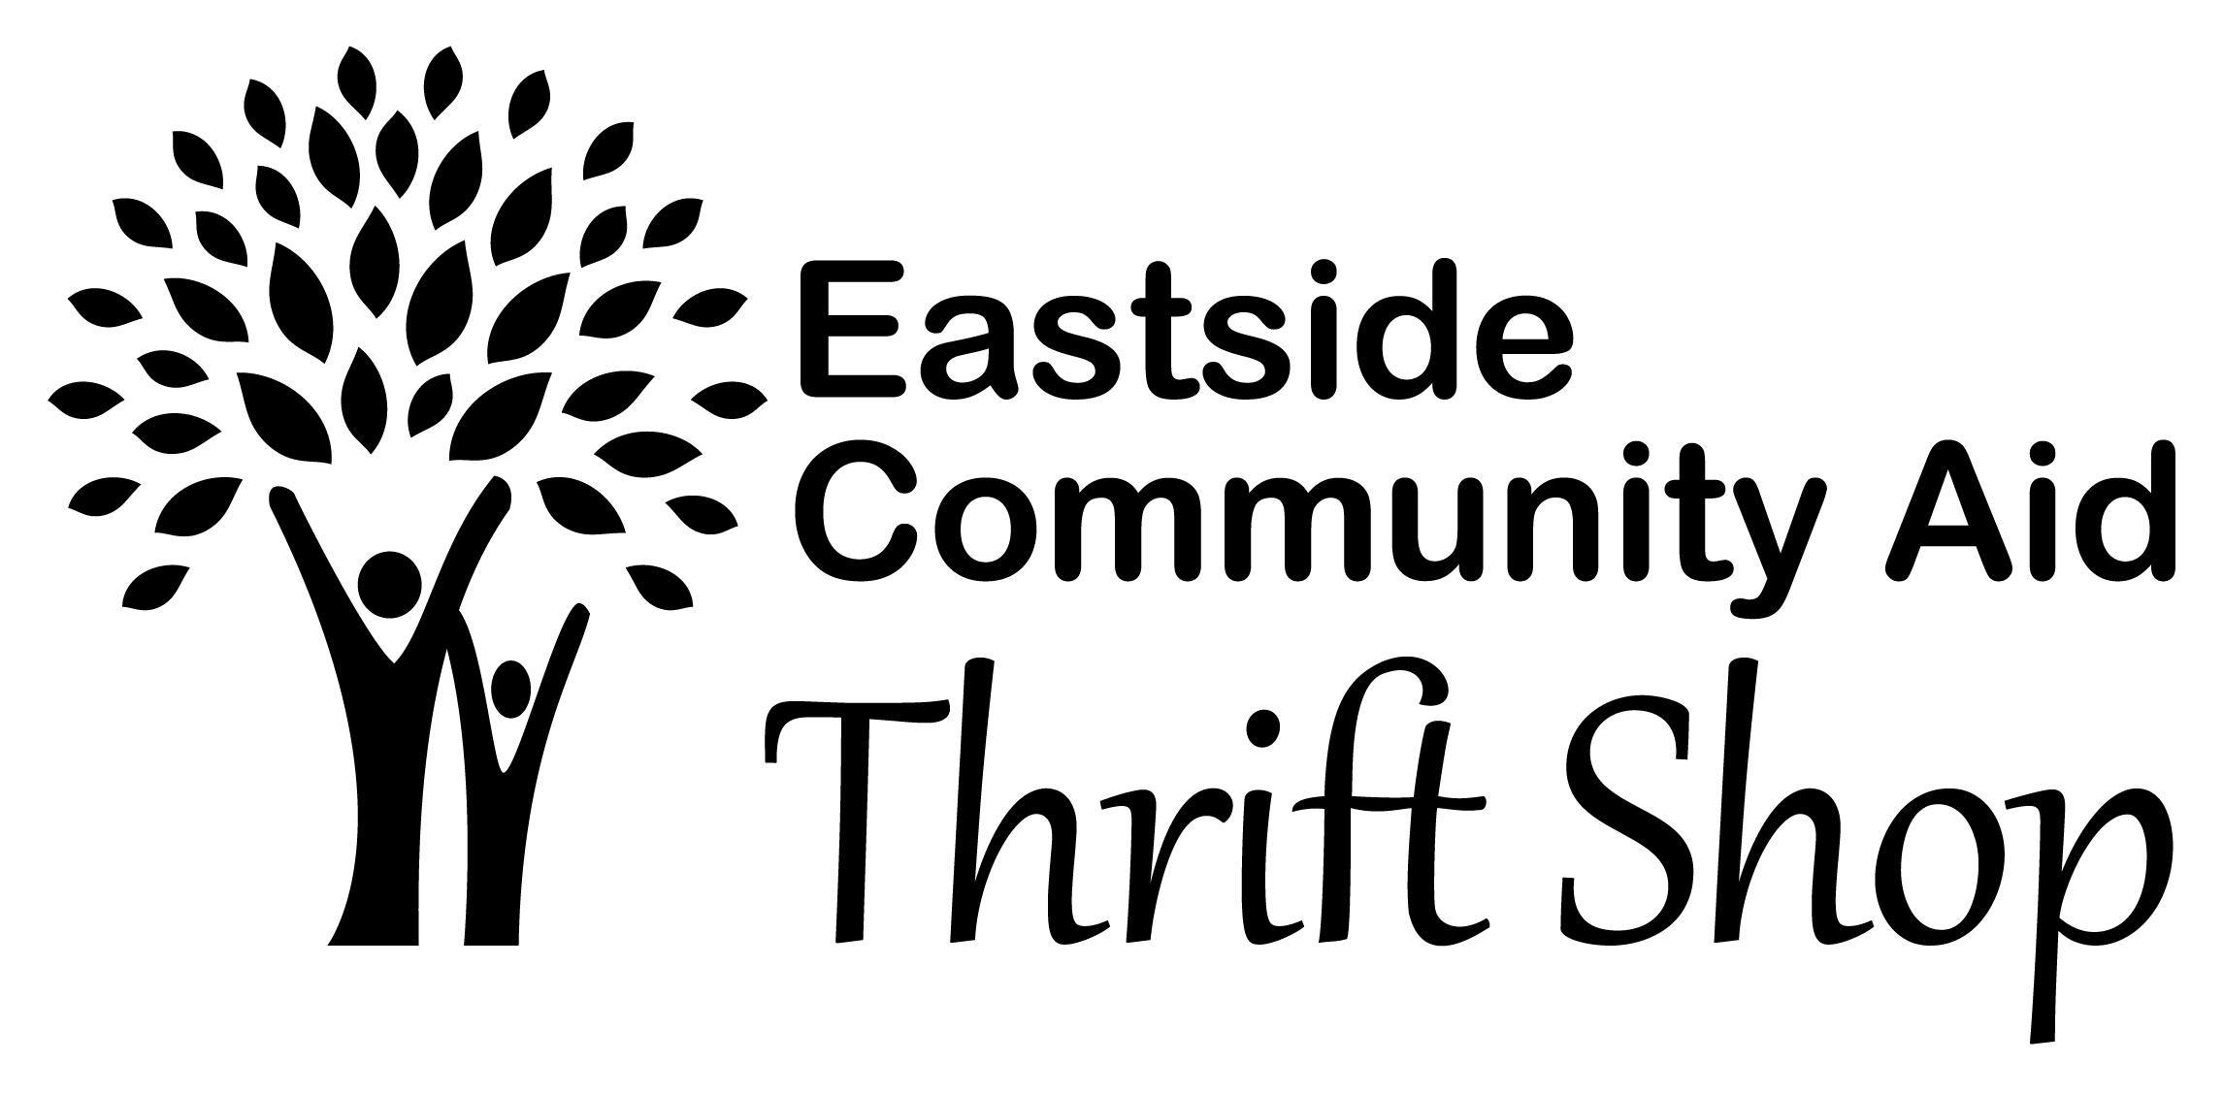

Grant Application and Instructions
Eastside Community Aid Thrift Shop (ECA) is a nonprofit, all-volunteer organization, chartered by the State of Washington as a nonprofit in November, 1981 and approved by Internal Revenue Service in November, 1990. Our primary source of funding is our Thrift Shop located in Kirkland, WA. ECA provides financial and material support to 501(c)3 organizations located in east King County, Washington. We provide grants for housing, hunger and mental health programs. This document includes the ECA Grant Application and instructions for completion.
Instructions
- Read our Grants page on the ECA website (http://ecathriftshop.org/grants.html) to learn about ECA grant eligibility and policies.
- Fill out the application (pages 2-4 of this document), saving it on your computer.
- Print the page that requires a signature and scan it onto your computer.
- Prepare the following attachments:
- Copy of your IRS 501C3 notification letter. If you have applied before, you do not need to include it.
- Copy of your current year budget.
- Cover letter that briefly summarizes your request.
- Send ONLY an electronic copy of your grant application to ecathriftshop@gmail.com.

If you have any questions about this process, please contact our Grants Chair, Susan Smith at sjsmith49@gmail.com.

EASTSIDE COMMUNITY AID GRANT APPLICATION

- ORGANIZATION INFORMATION

ORGANIZATION
NAME/ ADDRESS/
WEBSITE

EIN NUMBER
CONTACT PERSON’S NAME/ PHONE/ EMAIL

CHIEF OFFICER’S NAME AND TITLE
ORGANIZATION’S MISSION STATEMENT

- PROJECT INFORMATION

GRANT AMOUNT REQUESTED
DESCRIPTION OF PROJECT—

BE EXPLICIT IN HOW IT ADDRESSES HOUSING, HUNGER, OR MENTAL HEALTH OF EASTSIDE RESIDENTS

PROJECT TIMELINE—START DATE AND COMPLETION DATE
GEOGRAPHIC AREAS BEING SERVED

- BUDGET AND ACCOUNTABILITY
DESCRIPTION OF THE BUDGET FOR THIS PROJECT, INCLUDING HOW ECA FUNDS WOULD BE USED

INCLUDE DETAILS OF OTHER SOURCES OF FUNDING FOR THIS PROJECT, IF ANY

DETAIL WHAT METRICS YOU WILL USE TO ASSESS THE IMPACT AND EFFICACY OF THIS PROJECT

FUNDS FROM ECA MUST BE SEPARATELY TRACKED FOR THIS PROJECT. INITIAL HERE TO AGREE TO PROVIDE TRACKING DOCUMENTATION.

- PARTNERING WITH ECA

ECA prioritizes grant funding for small, grass roots programs that directly address housing, hunger, or mental health on the Eastside. We also aim to partner with every organization we fund in a mutually beneficial relationship that provides increased exposure for both organizations.

Grant recipients are required to participate in a meeting (in person or Zoom) within 30 days of receipt of funds. The aim of this meeting is to brainstorm ways our organizations can mutually support one another. Another meeting will be scheduled at completion of the funded project to assess the impact of our joint efforts. The following suggestions illustrate how our organizations could support one another.

- Include ECA in your donor list and ECA will include your organization in our publications. Our list of partners is on our website and will be prominently displayed inside our shop.
- Reciprocal inclusion of each other’s logo on our websites.
- Reciprocal articles about each other in our newsletters.
- Reciprocal social media posts.
- Refer callers to us who have items to donate.
- Post an ECA Volunteer Recruiting flyer in your workplace. More ECA volunteers means we can staff more hours/days and increase our sales.
- Possible co-sponsored events.
- Share your suggestions for how to mutually support both of our organizations.

- SIGNATURES
SUBMITTER’S NAME

SUBMITTER’S SIGNATURE

DATE

